TEO Annotation guideline

## How to install Protégé and Semantator

1. Download Protégé and install it (http://protege.stanford.edu/products.php#desktop-protege).
2. Download Semantator, (<https://sbmi.uth.edu/dotAsset/4d787a4e-9fb7-4e5e-8059-14a4a41c86f0.zip>). Unzip the zip file in 'plugins' directory of Protégé.
3. Open Protégé, click window🡪tab🡪semantator.
4. How to use Semantator? (<https://sbmi.uth.edu/ontology/project/semantator.htm>)
5. Load TEO ontology in Protégé first, and then open text in Semantator and then begin to annotate.
6. Save the text you’ve annotated in Semantator and save the owl file in Protégé in turtle format. Save frequently and quit when you finish it. The format saved should be turtle. Saving steps are as following:

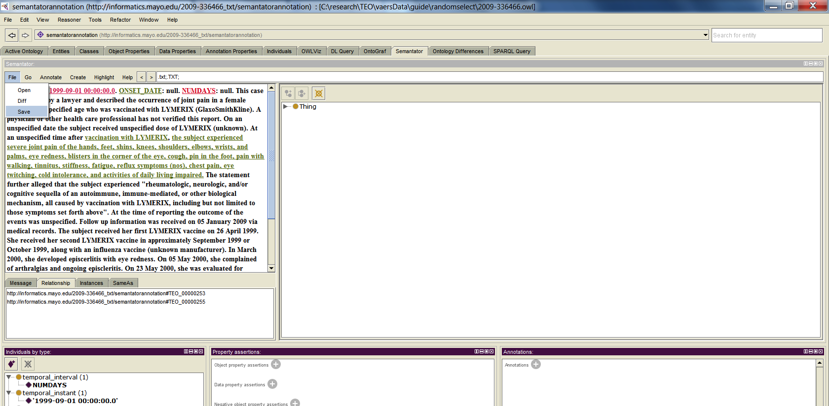

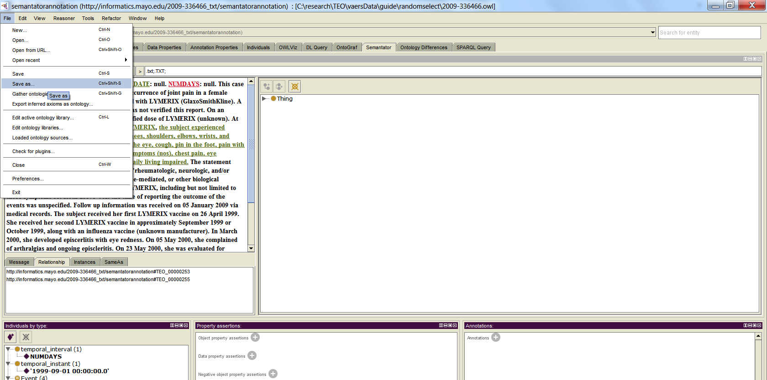

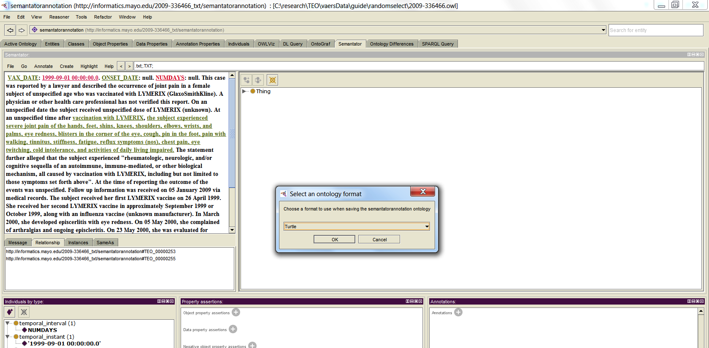

## Before annotation

1. Only annotate the sentences which have temporal information or you believe they have temporal information.
2. Only add properties and relationships that you can directly get from the sentence you are annotating, avoiding using information from other sentences unless it is necessary. It would be much complicate if you always try to get information from other sentences.
3. There are two main types of entity in TEO: event and time class. An event can be a diagnosis, physical state, medications and etc. Time can be an instant, an interval or a period time. An event can have some temporal relationship with another event or with another a time class, and a time class can also have some temporal relationship with another event or with another a time class. See Figure 1.
4. If we know the time of an event, the event hasValidTime with that time.

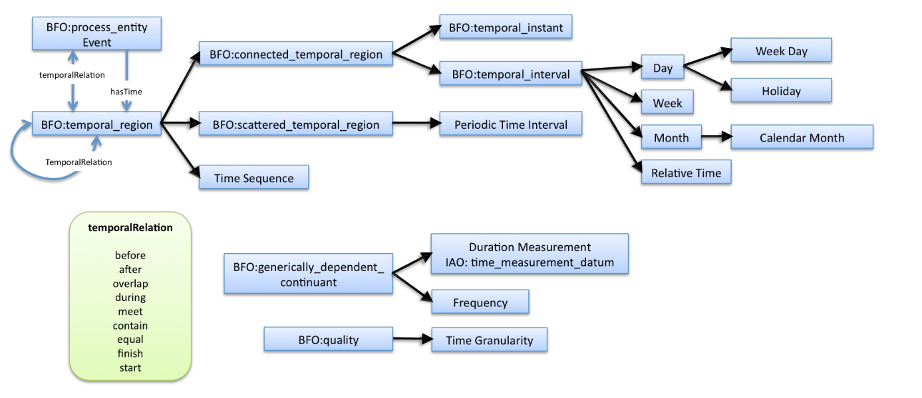

Figure TEO

## Event

An event can be a **diagnosis, physical state, medications** and etc.

Case 1. In March 2000, she developed episcerlitis with eye redness.

“March 2000” is the time class and “she developed episcerlitis with eye redness” is the event. We can select the “she developed episcerlitis with eye redness” and create it as an event.

Sometimes, the words you select may not cover all the information of the event. Under those cases, you may need to change the label of the event.

Case 2. On his last PT test in Sept/Oct time frame of 2007, he received his lowest PT score ever. His usual score was a 270-280, he received only a 220.

You may select “he received his lowest PT score ever” as the event, however the words cannot cover all the information; like that it’s his last PT test, his usual score and the score he received. In this case, we can select the words “he received his lowest PT score ever” as the event and change the label to “On his last PT test, he received his lowest PT score 220 while his usual score was a 270-280”.

## Temporal instant

For a temporal instant, there are two properties need to be added: **hasNormalizedTime** and **hasGranularity**. If the time point is not certain, for example use something like: “early next month” and “in approximately two weeks”. We should also add hasModality “false” to this time class. Add hasNormalizedTime and hasGranularity to the time instance.

Case 1. The subject received her first LYMERIX vaccine on 26 April 1999

Select “26 April 1999” and create it as a time instant.

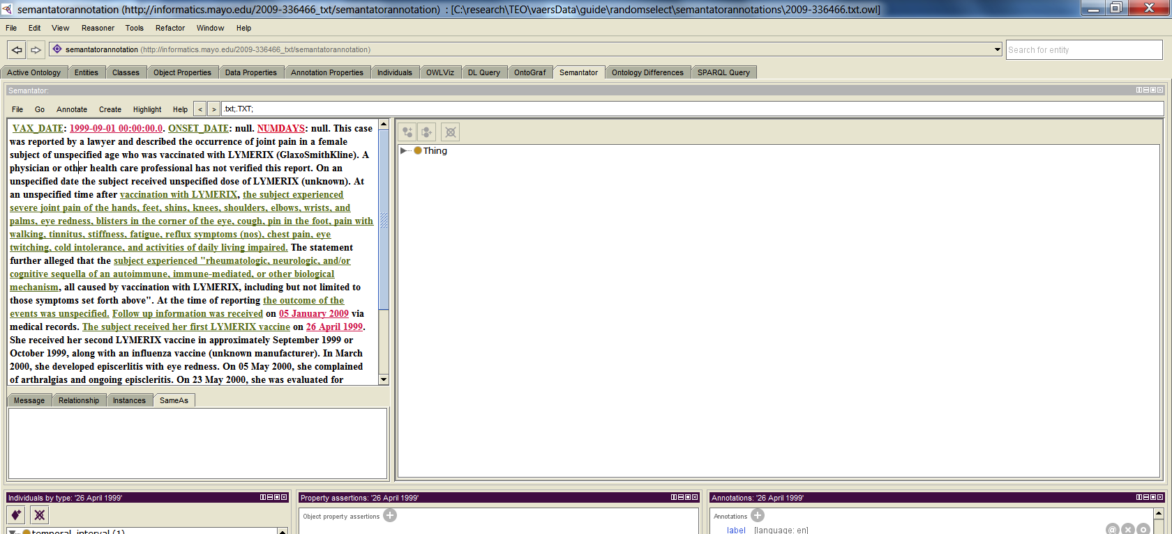

Case 2. On his last PT test in Sept/Oct time frame of 2007

This case is a little tricky. Actually, we can get that the event happened at a time instant during that time frame, but we don’t know the exact time of it. Our current TEO cannot handle this program very well. For the case and for now, we just assume that this event happened at the beginning of this time frame --- 2007-09 and hasGranularity “month” and hasModality “false”

Case 3. She received her second LYMERIX vaccine in approximately September 1999 or November 1999

The test could happen at two different time points. Under this case, we just assume the test happened at the first time point and the time instance hasModality “false”.

Format:

Assume we know the time is 10:30:45 2009-05-15, if the granularity is second, use this format: 10:30:45 2009-05-15; it the granularity is day, use this format: 2009-05-15;if the granularity is month, use this format: 2009-05; if the granularity is year, use this format: 2009. For hasGranularity, you can type the following: second, minute, hour, day, week, month, or year. If you can’t get the time or the granularity information from the text, just do not add the unknown properties.

## Temporal interval

For a temporal interval, we should at least add two of these three properties: **hasDurationPattern, hasStartTime and hasEndTime. hasDurationPattern** is a data property. The format of this property is “4Y5M3W0D0H0m0s”. For example, if the time last for 3 months, the hasDurationPattern should be “3M”. hasStartTime and hasEndTime are object properties, which means that we should link it with a temporal instant. Do not add all the three properties, as it may cause inconsistence. Also, if this time class is not certain, we should add hasModality “false” to it.

Case 1. monitor patient’s heart rate for 72 hours starting from today (note date:2004-06-01)

Select “today” and create it as a temporal instant and add hasNormalizedTime “2004-06-01” and hasGranularity “day” to the time instance. Then select 72 hours and create it as a temporal interval. Add hasDurationPattern “72H” to the temporal interval and add hasStartTime and link it with the temporal instant “today” we just created.

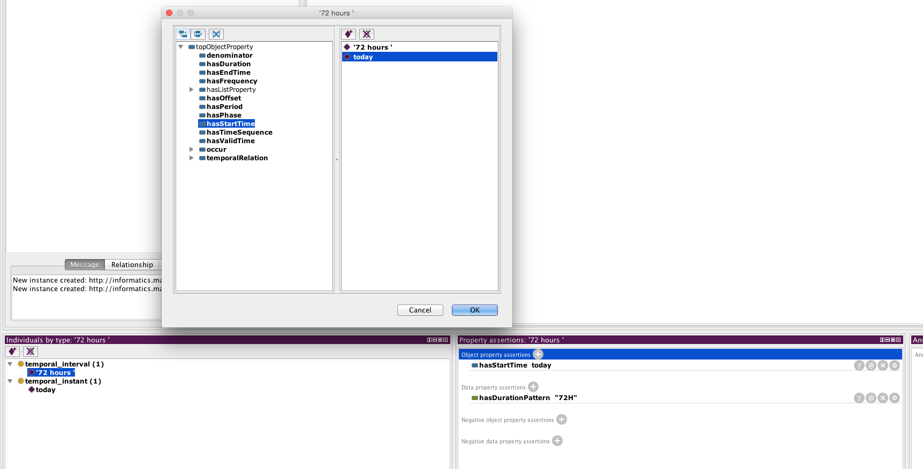

Case 2. see the patient back in approximately two weeks prior to his third cycle of chemotherapy

Select “approximately two weeks” and create it as a temporal interval. We can only know the approximate duration of this interval and do not the start time or the end time. So we need add hasDurationPattern “2W” to this instance and add hasModality “false” to it.

## Periodical Time interval

Many clinical events recur periodically. Here is a case to annotate periodical time:

Case 1. take antibiotics every 8 hours for 10 days starting from today (note date:2004-06-01)

Select “today” and create it as a temporal instant and add hasNormalizedTime “2004-06-01” and hasGranularity “day” to the time instance. Select “10 days” and create it as a temporal interval, and add hasDurationPattern “10D” to it. Select “every 8 hours” and create it as a timePeriod and add hasOriginTime “every 8 hours” to it. Then select “every 8 hours for 10 days” and create it as a timePhase. Add hasDuration with “10 days” and add hasStartTime with “today” and add hasPeriod “every 8 hours” to it.

## Add relationship

There are two ways to add relationship between two instances. One way is to add two instances in the relationship list and create the relationship as shown in (<https://sbmi.uth.edu/ontology/project/semantator.htm>). This way is a little complicate, as you have to clear the relationship list first and be careful about the object and subject. Also, after you create the relationship, it may hard to find whether you’ve create it or not and it is also very difficult what relationships you have created so far.

Thus, I recommend another way to create the relationship by adding the object properties.

Case 1. Hospital admit 1/08. Developed migraine HA after LP.

Select the first event as the object and click to add object property. Find the appropriate relationship and link it to the subject event or time instance. See the following:

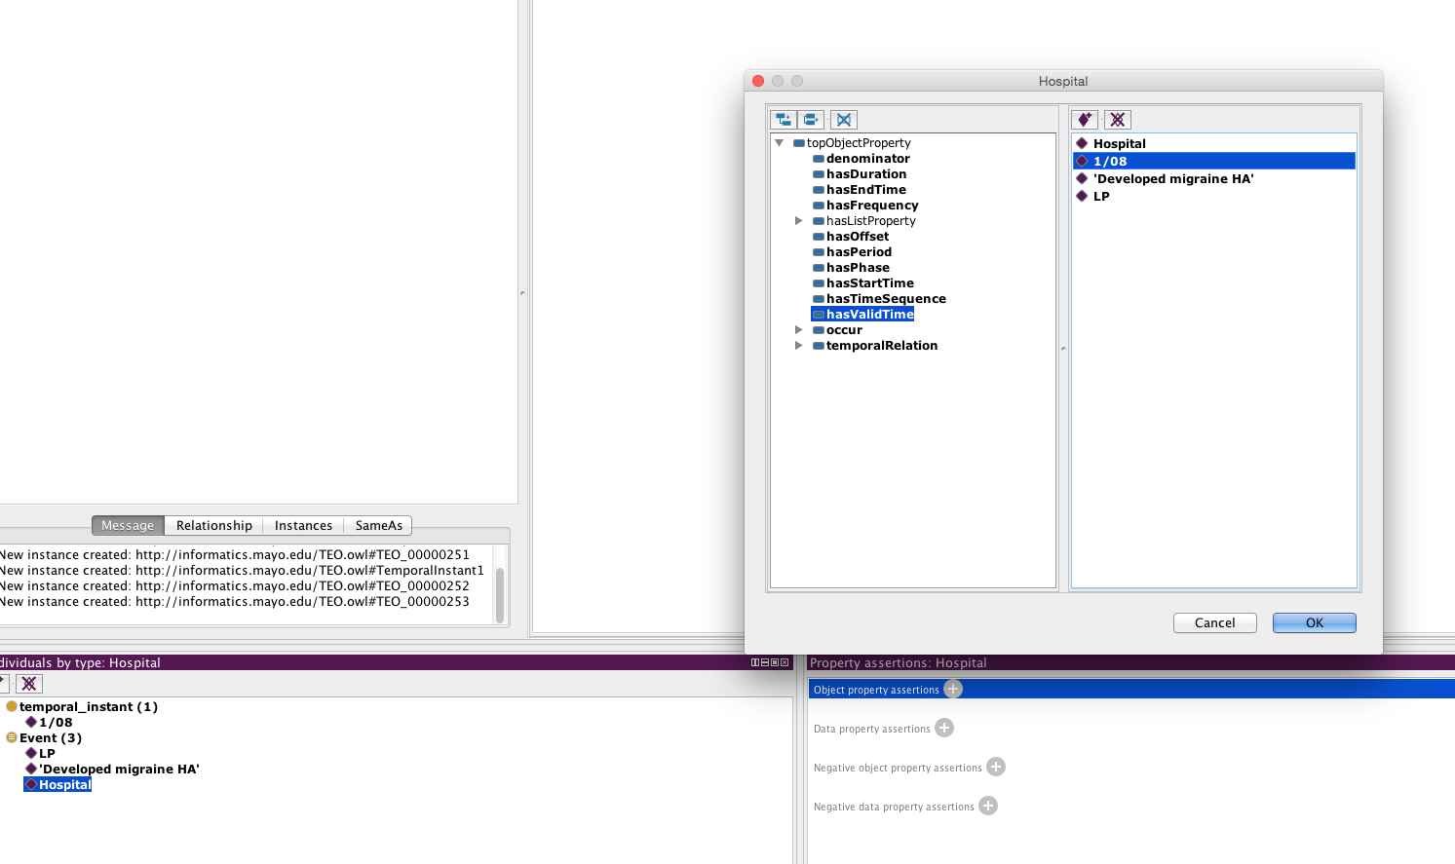

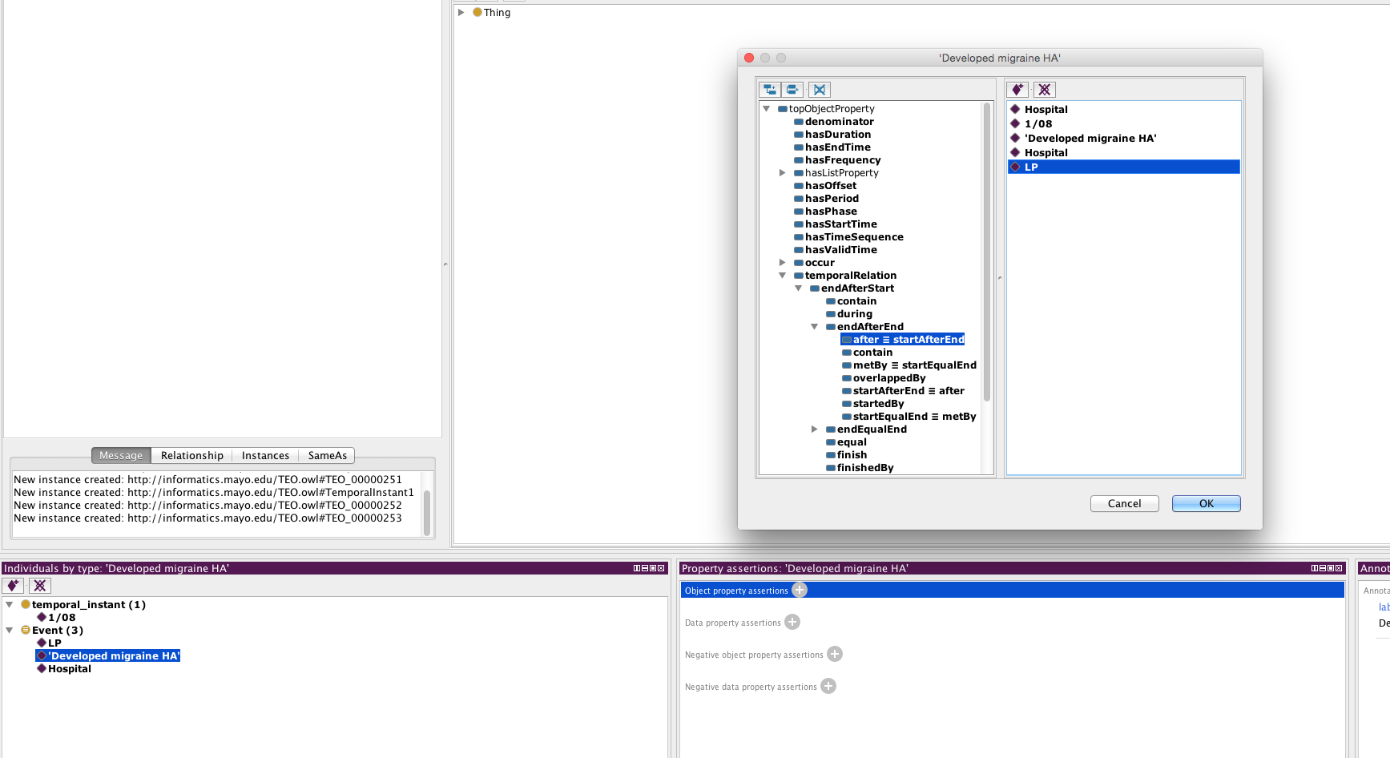

## What kinds of temporal relation do we have?

Relationship between temporal interval and temporal interval

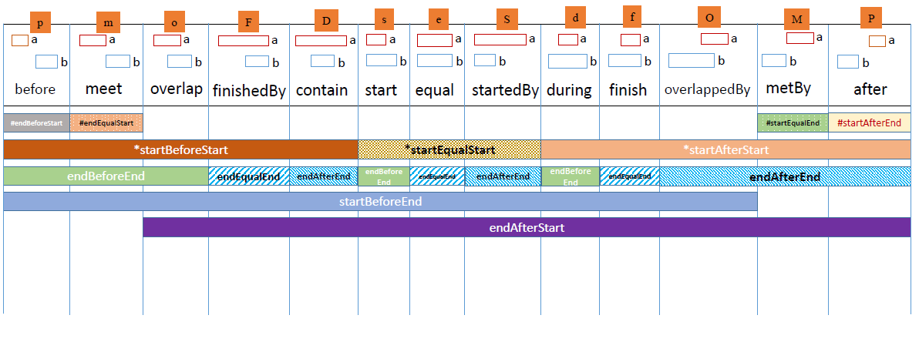

Relationship between temporal instant and temporal interval

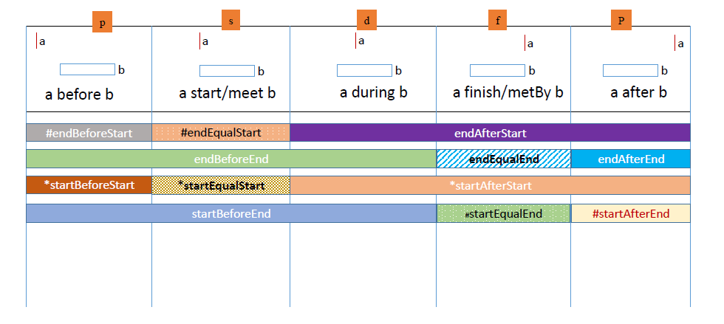

Relationship between temporal instant and temporal instant

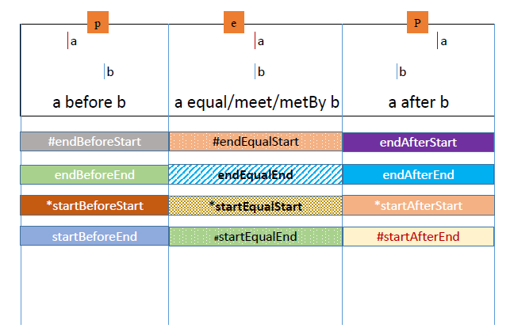

Note that, above temporal interval and temporal instant could be both time instances and the events that happen at a temporal instant or during a temporal interval. If the time instance is a periodical time, we just treat it as a temporal interval.

As we can see, in the same situation, there may be several relationships you can choose from. Try to select the relationship that has the least coverage. For example, when consider a temporal instant – temporal interval relationship, if a finish by/metBy b, you should choose “endEqualEnd” or “startEqualEnd” instead of “endAfterStart” or “startAfterStart”

## Annotate the relationship

If A ends before B starts, A is before B for a certain duration or we can say B is after A for a certain duration. We could annotate that relationship.

Case 1. patient’s bilirubin is elevated 2 weeks after the second cycle of chemotherapy.

We know that “patient’s bilirubin is elevated” is after “the second cycle of chemotherapy”. “2 weeks” is a temporal interval and we can use “2 weeks” to annotate the “after” relationship. Here are the steps:

1. Create the two events and create their relationship

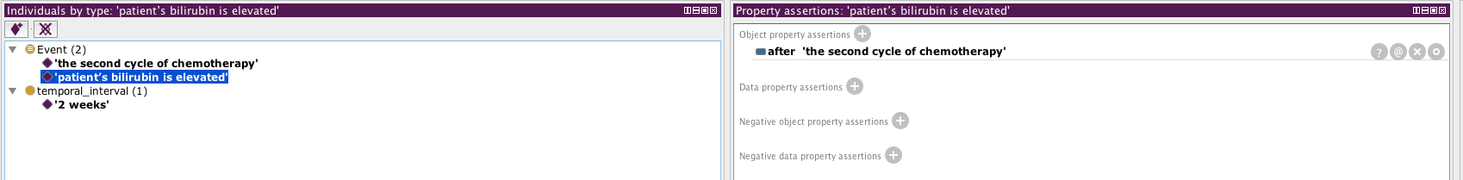

2. Click “@” to annotate the relationship:

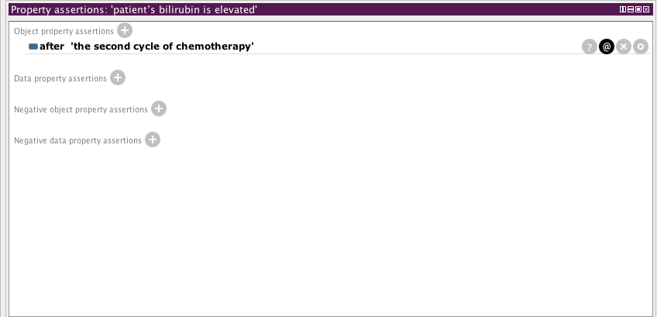

3. Add annotation

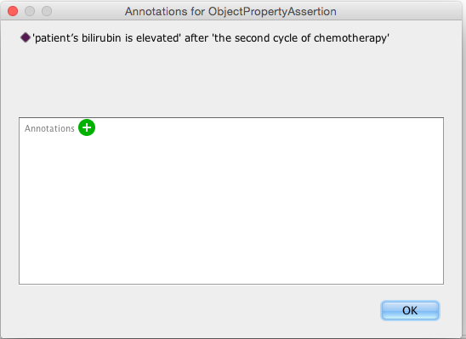

3. Select hasTimeOffset on the left. Select “Entity IRI” tab, then “Individuals” tab. Then select the “2 weeks” individual.

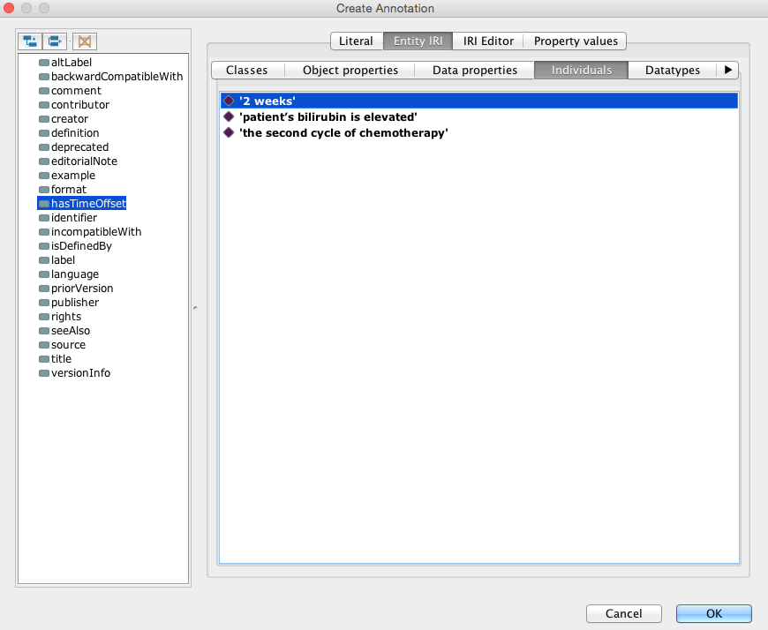

4. After click “ok”, the “@” tab becomes yellow

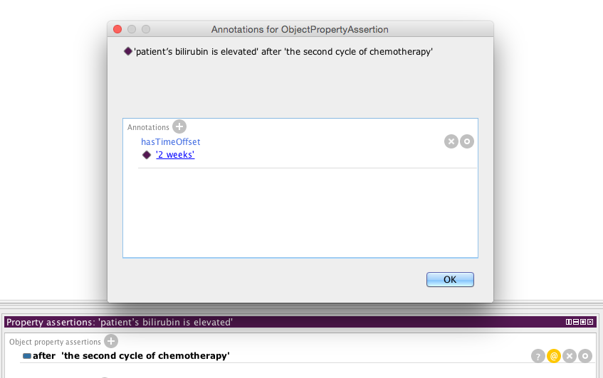

## Class hierarchy

